**Problem Statement**

Danny wants to use the data to answer a few simple questions about his customers, especially about their visiting patterns, how much money they’ve spent and also which menu items are their favourite. Having this deeper connection with his customers will help him deliver a better and more personalised experience for his loyal customers.

He plans on using these insights to help him decide whether he should expand the existing customer loyalty program - additionally he needs help to generate some basic datasets so his team can easily inspect the data without needing to use SQL.

Danny has provided you with a sample of his overall customer data due to privacy issues - but he hopes that these examples are enough for you to write fully functioning SQL queries to help him answer his questions!

Danny has shared with you 3 key datasets for this case study:

* sales
* menu
* members

You can inspect the entity relationship diagram and example data below.

**Entity Relationship Diagram**

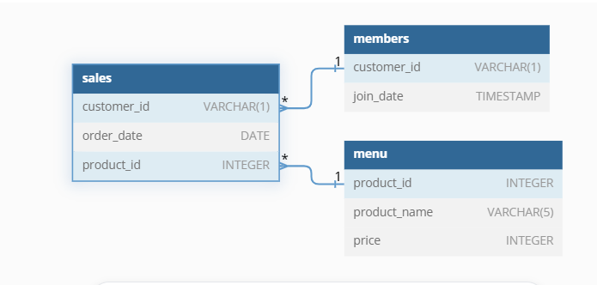

**Case Study Questions**

Each of the following case study questions can be answered using a single SQL statement:

1. What is the total amount each customer spent at the restaurant?
2. How many days has each customer visited the restaurant?
3. What was the first item from the menu purchased by each customer?
4. What is the most purchased item on the menu and how many times was it purchased by all customers?
5. Which item was the most popular for each customer?
6. Which item was purchased first by the customer after they became a member?
7. Which item was purchased just before the customer became a member?
8. What is the total items and amount spent for each member before they became a member?
9. If each $1 spent equates to 10 points and sushi has a 2x points multiplier - how many points would each customer have?
10. In the first week after a customer joins the program (including their join date) they earn 2x points on all items, not just sushi - how many points do customer A and B have at the end of January?

-------------------Answers-----------

---------Case Study Questions---------

--What is the total amount each customer spent at the restaurant?

select customer_id as Customer,SUM(Price) as Total_Amountspent from sales A

inner join menu B on A.product_id = B.product_id group by customer_id

---How many days has each customer visited the restaurant?

select customer_id as Customer,order_date,count(DATEPART(Day,order_date)) as NoofTimes_visited from sales A

inner join menu B on A.product_id = B.product_id group by customer_id,order_date

--What was the first item from the menu purchased by each customer?

select customer_id,product_name from (select A.customer_id,dense_Rank() over(partition by A.customer_id order by Day(order_date)) as Rank,product_name from sales A

inner join menu B on A.product_id = B.product_id )As A where Rank =1

----What is the most purchased item on the menu and how many times was it purchased by all customers?

with MostPurchased as(

select product_name,COUNT(product_name) as Totapurchased from sales A

inner join menu B on A.product_id = B.product_id

group by product_name

d

)

select customer_id,count(A.product_id) as Nooftimespurchased from sales A

inner join menu B on A.product_id = B.product_id

where product_name = (select top 1 product_name from MostPurchased group by product_name order by count(product_name) desc)

group by customer_id

---Which item was the most popular for each customer?

WITH ProductCounts AS (

SELECT

customer_id,

A.product_id,

product_name,

COUNT(*) AS purchase_count

FROM

sales A

inner join menu B on A.product_id = B.product_id

GROUP BY

customer_id, A.product_id, product_name

),

RankedProducts AS (

SELECT

customer_id,

product_id,

product_name,

purchase_count,

ROW_NUMBER() OVER (PARTITION BY customer_id ORDER BY purchase_count DESC) AS rank

FROM

ProductCounts

)

SELECT

customer_id,

product_id,

product_name,

purchase_count

FROM

RankedProducts

WHERE

rank = 1;

----------

--Which item was purchased first by the customer after they became a member?

with CTE as (

select A.customer_id,A.order_date,A.product_id,B.product_name,B.price,C.join_date,

case when order_date >join_date then 'Orders After Joining' else 'Orders before joining' End as Category

from sales A

inner join menu B on A.product_id = B.product_id

inner join members C on A.customer_id = C.customer_id ),

FirstpurchasedItems As(

select *,RANK() over(partition by customer_id order by order_date) as Rank from CTE where Category = 'Orders After Joining')

select customer_id,product_name from FirstpurchasedItems where Rank = 1

-------

---Which item was purchased just before the customer became a member?

with CTE as (

select A.customer_id,A.order_date,A.product_id,B.product_name,B.price,C.join_date,

case when order_date >join_date then 'Orders After Joining' else 'Orders before joining' End as Category

from sales A

inner join menu B on A.product_id = B.product_id

inner join members C on A.customer_id = C.customer_id ),

FirstpurchasedItems As(

select *,RANK() over(partition by customer_id order by order_date desc) as Rank from CTE where Category = 'Orders before joining')

--select * from FirstpurchasedItems where Rank = 1

select customer_id,product_name from FirstpurchasedItems where Rank = 1

----What is the total items and amount spent for each member before they became a member?

select count(product_id) as TotalItems_Purchased,sum(price) as Total_price from (select A.customer_id,A.order_date,A.product_id,B.price,B.product_name,

case when order_date >join_date then 'Orders After Joining' else 'Orders before joining' End as Category

from sales A

inner join menu B on A.product_id = B.product_id

inner join members C on A.customer_id = C.customer_id ) as A where Category = 'Orders before joining'

--If each $1 spent equates to 10 points and sushi has a 2x points multiplier - how many points would each customer have

select customer_id,

sum(case when product_name = 'sushi' then price*20 else price *10 end) TotalPoints

from sales A

inner join menu B on A.product_id = B.product_id group by customer_id

----------

--In the first week after a customer joins the program (including their join date) they earn 2x points on all items, not just sushi

--- how many points do customer A and B have at the end of January?

select A.customer_id,

sum(case when product_name = 'sushi' then price*20

when order_date>=join_date then price *20

else price * 10 end) TotalPoints

from sales A

inner join menu B on A.product_id = B.product_id

inner join members C on A.customer_id = C.customer_id where MONTH(A.order_date)<2 group by A.customer_id

-------------